Installation Guide and Project Description for
LinqCommerce 3.2
An open source E-Commerce module using LINQ

By Joseph Anderson, MCP
11/9/2009

Table of Contents

Introduction 3
About the Project 3
What’s new in LinqCommerce 3.2 3
Digital Product Support 4
Store 4
Store Front 4
Administration 5
Web.config Demystified 6
Section Group Element Properties 6
Payment > PayPal 6
SiteSettings > ShoppingCartSettings 7
SiteSettings > ProductSettings 7
AuthorizeNETSettings 8
Upgrading from LinqCommerce 3.1 to LinqCommerce 3.2 8
Installation 8
Installing Sitefinity CMS or ASP.NET Application 8
Configuration 9
Database 12
Membership, Roles and Profiles 12
Connection String 12
Amazon Access ID 12
Amazon Search Index 12
Amazon Associates 12
Best Buy Remix API 12
Payment Providers 13
PayPal Integration – Website Payments Standard 13
PayPal Integration – PayPal PayFlow Pro 13
Authorize.NET – AIM 14
Switching from Test to Live Mode 14
After the Order Has Been Placed 14
Google Checkout 14
Tutorials 15
Getting Started with the Admin 15
Introduction 15
Adding Products to the Admin 15
Tax and Shipping 15
Coupons 16
Inventory 16

Introduction
This whitepaper will discuss installing LinqCommerce as part of another ASP.NET application, such as the Sitefinity CMS, and discuss LinqCommerce’s general functionality. Ultimately, this tool will share the same database as the other application, so security and profile info will be the same, but LinqCommerce will have its own tables and stored procedures. In LinqCommerce 3.0, a back up of a database is included, so you can run this project and another ASP.NET application with two databases.

About the Project
This project’s purpose is to demonstrate the use of LINQ, especially in making an E-Commerce store. This should serve as a sample for other software developers implementing 3rd party e-Commerce applications into the Sitefinity CMS or another application.
Since this application would be placed inside of Sitefinity, or another ASP.NET application, no security has been implemented. This solution is not meant to be a commercial Sitefinity module, but rather an open source project that could be improved and used for the community. To run the project on its own, restore the back up, located in the App_Data folder, onto a blank database.
Portions of this open source project were adapted from Christian Darie’s E-Commerce book, “Beginning ASP.NET 2.0 E-Commerce in C# 2005.” From his book, the entire application was broken down into user controls, using LINQ for the Data Access Layer, and using some of Telerik’s RadControls for ASP.NET AJAX. I also used PayPal IPN code from XDev Info and advice from Rick Strahl’s article on Website Standard Pro.

What’s new in LinqCommerce 3.2
The following features have been added:
- Digital product support through Google Checkout
- New image display control when viewing product details, using jQuery
- Store admins can upload a large picture of the product to be displayed in the product details section
- Fixed bugs with uploading images
- CSS upgrades for product details
- CSS upgrades for uploading multiple images in admin
- Adding categories to a product is now its own separate page
- Utilities.cs was excluded because ASP.NET Health Monitoring can be used in its place
- Web.config error settings section, under LinqCommerce, was removed
- When credit cards are accepted directly, LinqCommerce records the billing and shipping data into the system

Digital Product Support
LinqCommerce supports the sale of digital products. For more info, please visit our video page.

Store
The store has 3 main parts: a store front, an administration area and a configuration section.

Store Front
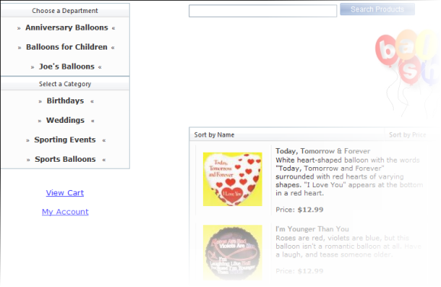
These files are contained in the LinqControls > ControlTemplates folder. When the user visits the store, he or she picks categories from a list on the left. When a user selects a department, the hyperlink control appends a department ID to the query string. From there, a list populates in the middle with product related to the department and category. Until the list has been drilled down to the end, the user will see products special promotion. The product list returns a certain number of records and paging is computed by the RadGrid products list. Users can also search by product, using the RadComboBox’s load on demand feature.
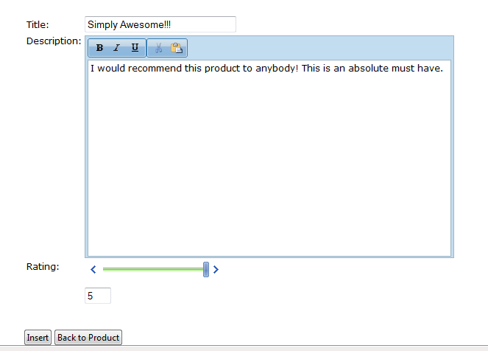
After a product is selected, the user is brought to the product details page. The user can add the product to the shopping cart, change the quantity added to the cart, select a color, select a size or write a review. After a user submits a review, the admin must log-in, go to the reviews administration section, and check off the review as approved. The user can also read these comments and sort them based on score or date submitted. Then, the user can view products that other customers have purchased from the site.
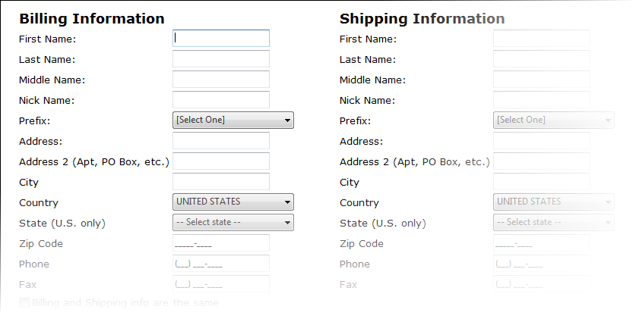
Users can also login to the store and view certain pages, such as being able to edit their profile. This info is used to populate the credit card checkout page, ~/Checkout.aspx. Users can complete their profile, recover or change their password using the security system. They can also track their orders. The ASP.NET 3.5 security controls were used for the project, so the entire API is the same from the .NET Framework.
When the user has finished shopping, he or she can click on the view cart link and go to the shopping cart. The cart is a RadGrid that pulls the shopping cart ID from session state. When a user adds items to the cart, LinqCommerce inserts database records and the cart ID links them all together. The cart will deactivate options to add quantity and checkout without records, based on a LINQ query. The cart will adjust quantity based on the row’s column and the price will adjust based on that number based on another LINQ query.
After inserting items into the cart, the user can select PayPal, Google Checkout, or the credit card can be processed on the site directly. For more info on payment providers, please refer to the payment section of the manual.

Administration
The store is administered in four main sections. These include the order catalog, shopping cart, coupon and order administration sections.
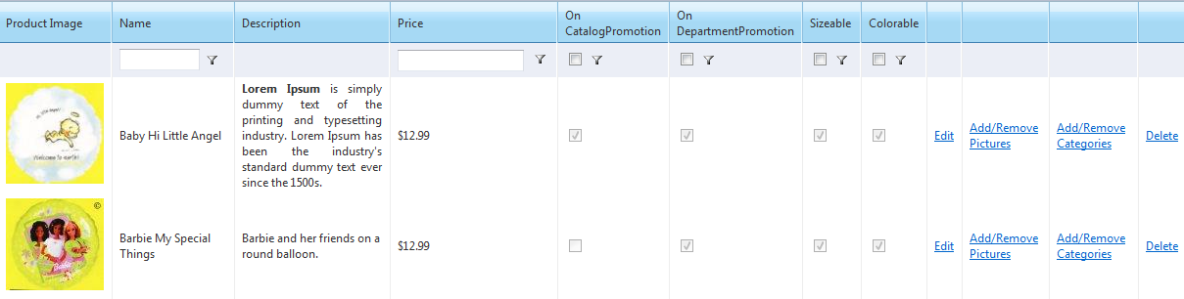
The product catalog is administered by a page called catalogadmin.aspx. Catalogadmin.aspx loads a user control based on query string fields. A list of departments appears first. When a department is selected, the hyperlink adds a department ID to the query string. A second grid appears showing categories within the department. The process repeats itself and a list of products is now shown based on that category.
There is also a shopping cart admin to empty out carts where the user never checked out. This is the equivalent of people shopping at your store, placing items in the cart, leaving the carts behind and leaving the store. This removes unnecessary data from the database and makes it smaller. 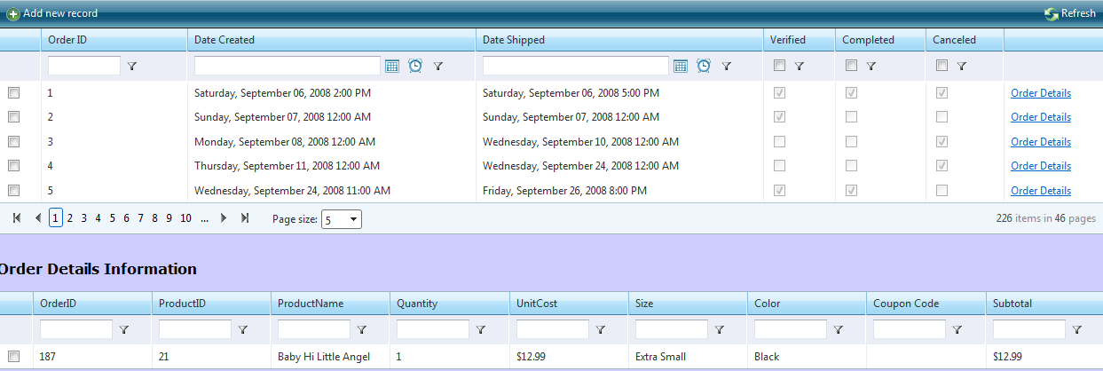OrdersAdmin.aspx maintains information about the order itself, such as who ordered it and what was sent. Two RadGrids were used to display this information. One queries the orders table and the other one queries the order details table. The second grid is populated based on a query string provided by the first grid’s hyperlink column.

Web.config Demystified
The Web.config has these main parts:

Section Group Element Properties
These control properties such as cart persist days and your PayPal e-mail account. Here is a full listing of the fields that need to be added to your Web.config:

Payment > PayPal
Name | Description | Sample Value
PayPalEnvironment | Sandbox or Live for PayPal Website Payments Standard. Tells system whether you’re in a test or live mode. | Sandbox
PayPalEMailAccount | PayPal E-mail account for Website Payments Standard | joe@google.com
URLReturn | URL PayPal sends user after successful order from Website Payments Standard | http://www.mysite.com
URLCancel | URL PayPal sends user if order is canceled for Website Payments Standard | http://www.yahoo.com
PayPalHeaderImage | URL for header image on cart for Website Payments Standard | http://www.mysite.com/image.jpg
UserID | UserID for PayPal PayFlow Pro | Joe123
VendorID | Same value as UserID | Joe123
PayFlowPassword | Password for PayFlow Pro | 12345
Partner | Just enter PayPal | PayPal

SiteSettings > ShoppingCartSettings
Name | Description | Sample Value
RecentProducts | Number of days of product is new, so it is displayed with newest product query | -365
SiteName | Name of website and used for PayPal Website Payments Standard | BalloonShop
CartPersistDays | Number of days cart remains full, if user decides to leave and come back later | 10

SiteSettings > ProductSettings
Name | Description | Sample Value
EnableInventory | Boolean that turns on or off inventory feature | False
EnableRecommendedProducts | Boolean that turns on or off product recommendations | False
EnableProductReviews | Boolean that turns on or off product reviews | True
EnableWishList | Boolean that turns on or off wish list | True
ProductImagePath | File location of product images folder | ~/ProductImages/
ImageThumbMaxWidth | Max width for image thumbnail, displayed in ~/Catalog.aspx | 225
ImageThumbMaxHeight | Max height for image thumbnail, displayed in ~/Catalog.aspx | 100
ImageDetailMaxWidth | Max width for image detail, displayed in ~/product.aspx | 100
ImageDetailMaxHeight | Max height for image detail, displayed in ~/product.aspx | 100

AuthorizeNETSettings
Name | Description | Sample Value
APILogin | API Login for Authorize.NET | Joe123
TransactionKey | Transaction Key for Authorize.NET | Abcd1234435e456

Upgrading from LinqCommerce 3.1 to LinqCommerce 3.2
This involves swapping all of the files from LinqCommerce 3.2 to the 3.1 version. The Product Image table has two new columns called title and description. Please reference the Stored Procedure and Table guide for more info on database upgrades. The Web.config has also changed and a new section called Product Settings has been added. It is highlighted in step one in Installation > Configuration.

Installation

Installing Sitefinity CMS or ASP.NET Application
Information on installing the Sitefinity CMS can be found in its own Installation Manual. Once Sitefinity is installed, you need to copy all of the files from the LinqCommerce web site into the Sitefinity website, then you must adjust the Web.config. You must also run the database scripts, which is detailed below this paragraph.

Configuration
Follow these steps to set-up the Web.config file for the application:

- Add this code to your Web.config:

<section name="performanceCounter" type="Telerik.Framework.Utilities.HealthMonitoring.Configuration.CountersSection, Telerik.Framework" />
<section name="storageSetting" type="Telerik.Libraries.AmazonStorage.StorageSection, Telerik.Libraries" requirePermission="false" />
<section name="mediaProvider" type="Telerik.Libraries.MediaProvider.Configuration.MediaProviderSection, Telerik.Libraries" requirePermission="false" />
</sectionGroup>
<!--End of Telerik Section Group-->
<!--Insert LinqCommerce Section Groups Here-->
<sectionGroup name="LinqCommerce" type="LinqCommerce.SectionConfigurationGroup">
<section name="Payment" type="LinqCommerce.SectionConfigurationGroup"/>
<section name="SiteSettings" type="LinqCommerce.SectionConfigurationGroup"/>
<section name="AmazonSettings" type="LinqCommerce.SectionConfigurationGroup"/>
<section name="AuthorizeNETSettings" type="LinqCommerce.SectionConfigurationGroup"/>
</sectionGroup>

<storageSetting defaultProvider="Amazon">
<providers>
<add name="Amazon" type="Telerik.Libraries.AmazonStorage.AmazonStorageProvider, Telerik.Libraries" downloadUrlPrefix="http://s3.amazonaws.com" accessKey="#YourAccessKey#" secretAccessKey="#YourSecrectKey#" bucketName="Sitefinity" />
</providers>
</storageSetting>
<!-- Viddler-->
<mediaProvider defaultProvider="viddler">
<providers>
<add name="viddler" type="Telerik.Libraries.MediaProvider.ViddlerProvider" apiKey="#Your_Api#" baseUrl="http://api.viddler.com/rest/v1/" />
</providers>
</mediaProvider>
</telerik>
<!--End of Telerik Section Group-->
<!--Insert LinqCommerce Section Group Here-->
<LinqCommerce>
<Payment>
<PayPal PayPalEnvironment="sandbox"
PayPalEMailAccount="joe@google.com"
URLReturn="http://localhost/test/receiptpage.aspx"
URLCancel="http://localhost/test/LC3/ShoppingCart.aspx"
PayPalHeaderImage="http://www.mysite.com/myimage.jpg" UserID="joe" VendorID="joe" PayFlowPassword="" Partner="PayPal">

</PayPal>
</Payment>
<SiteSettings>
<ErrorHandlingSettings MailServer="smtp.mysite.com" EnableErrorLogEmail="true" ErrorLogEmail="test@mysite.com" ErrorLogEmailFrom="test@mysite.com"></ErrorHandlingSettings>
<ShoppingCartSettings RecentProducts="-365" SiteName="BalloonShop" CartPersistDays="10"></ShoppingCartSettings>
<ProductSettings
EnableInventory="true"
EnableRecommendedProducts="true"
EnableProductReviews="true"
EnableWishList="true"
ProductImagePath="~/ProductImages/"
ImageThumbMaxWidth="75"
ImageThumbMaxHeight="75"
ImageDetailMaxWidth="225"
ImageDetailMaxHeight="225"
>
</ProductSettings>

</SiteSettings>
<AuthorizeNETSettings>
<AuthorizeNET APILogin="" TransactionKey="">
</AuthorizeNET>
</AuthorizeNETSettings>
</LinqCommerce>

Please note that the values for the variables, like APILogin, are dummy value.

- Add a second connection string called BalloonShop to your Web.config, which should look something like this:
<connectionString>
<add name="BalloonShopConnectionString" connectionString="Data Source=JOSEPH\SQLEXPRESS;Initial Catalog=BalloonShop;Integrated Security=True" providerName="System.Data.SqlClient"/>
</connectionString>
Please note that the DBML file is seeking a connection string by this name, since LinqCommerce is an adjustment from another module as I said above.
- Add these highlighted lines below the profile provider:

<add name="Sitefinity" connectionStringName="DefaultConnection" applicationName="/" type="Telerik.DataAccess.AspnetProviders.TelerikProfileProvider, Telerik.DataAccess"/>
</providers>
<properties>
<add name="FirstName"/>
<add name="LastName"/>
<add name="MiddleName"/>
<add name="Prefix"/>
<add name="NickName"/>
<add name="Address"/>
<add name="Address2"/>
<add name="City"/>
<add name="State"/>
<add name="Zip"/>
<add name="Phone"/>
<add name="Fax"/>
<add name="Country"/>
<group name="Billing">
<add name="FirstName"/>
<add name="LastName"/>
<add name="MiddleName"/>
<add name="Prefix"/>
<add name="NickName"/>
<add name="Address"/>
<add name="Address2"/>
<add name="City"/>
<add name="State"/>
<add name="Zip"/>
<add name="Phone"/>
<add name="Fax"/>
<add name="Country"/>
</group>
<group name="Shipping">
<add name="FirstName"/>
<add name="LastName"/>
<add name="MiddleName"/>
<add name="Prefix"/>
<add name="NickName"/>
<add name="Address"/>
<add name="Address2"/>
<add name="City"/>
<add name="State"/>
<add name="Zip"/>
<add name="Phone"/>
<add name="Fax"/>
<add name="Country"/>
</group>
</properties>
Sitefinity has some of these variables defined, so just remove any of the highlighted profile properties above as necessary.

Database
LinqCommerce needs several database tables to function properly. Please download the database scripts, then run them on an existing database. Here are the steps to run scripts:
  - Go to Start > All Programs > SQL Server Management Studio 2005 (or 2008)
  - Login using your credentials
  - On the top left, click new query
  - Copy and paste all of the database scripts into the white box in the middle
  - From the database drop down, select your database
  - Click the red “!” button
Your database is now prepared to use LinqCommerce.

Membership, Roles and Profiles
If you’re using Sitefinity, then skip this section.
You can use the ASPNETDB.mdf with LinqCommerce. Then, you can set-up roles and users using that database. For more info, please go Website > ASP.NET Configuration in Visual Studio.

Connection String
Please note that no connection string has been set for this project, but the name of the connection string must be balloonshop, since the starter kit was adjusted from this book by Christian Darie. The scripts for the database are in the Docs folder and the Documentation section of the LinqCommerce CodePlex project.

Amazon Access ID
To retrieve product recommendations from Amazon, you'll need an Amazon Access ID. Sign up on this site to get one.

Amazon Search Index
These are the various sections of Amazon.com. By default, the value toys is used and other ones can be inserted. For more info, check out Amazon's webpage.

Amazon Associates
My API for Amazon Associates has been compiled and included in this project. To see its source, please visit my CodePlex project.

Best Buy Remix API
LinqCommerce can be integrated with Best Buy’s Remix API. This is like Amazon Associates, but you can advertise Best Buy products to sell. For more info, please visit my CodePlex project.

Payment Providers
LinqCommerce has the necessary code for Google Checkout, PayPal Website Payments Standard, Authorize.NET AIM, and PayPal PayFlow Pro. The last two are Gateways, so they allow you to accept credit cards directly on your website. The first two send you to a 3rd party site to accept payment, then notify your website that payment has been received. To set-up each provider, follow the steps below for the appropriate company.

PayPal Integration – Website Payments Standard
Before you can integrate PayPal, however, you must sign up for a PayPal Premier Account and Website Payment Standard. PayPal also offers other payment options for larger sites with more features, so you can sign up for these additional features if your customer requires them. I would also recommend reading PayPal’s extensive documentation on Website Payment Standard and their Sandbox Environment.

PayPal Integration – PayPal PayFlow Pro
You need to create a test account with them by following these steps:
- Go to https://manager.paypal.com
- Click “I would like to create a new account”
- Complete the first page only with dummy data
- Do not complete the page asking you to pay money, which is the second page
- Using the credentials that you created, insert them into the PayPal section of the Web.config:
<PayPal PayPalEnvironment="sandbox"
PayPalEMailAccount=" "
URLReturn="http://localhost/test/receiptpage.aspx"
URLCancel="http://localhost/test/LC3/ShoppingCart.aspx"
PayPalHeaderImage="http://www.nysite.com/balloonshoplogo.png"
UserID="jo4" VendorID="jo4"
PayFlowPassword="asdfasdf!!1t" Partner="PayPal">
</PayPal>

Depending on whether you are in test mode, you need to choose the URL to post PayPal variables. The code for this provider in this location:

~/App_Code/PaymentProviders/PayPal/Gateway/DoSaleComplete.cs

To enable live mode, so you’re accepting cards in the production environment, follow these steps:

- Find this line of code:

PayflowConnectionData Connection = new PayflowConnectionData("pilot-payflowpro.paypal.com", 443, 45, "", 0, "", "");

- Beneath this line of code, you’ll see the word “Live Server.” Comment the code from step 1 and uncomment the PayflowConnectionData code beneath Live Server.

Authorize.NET – AIM
You need to create a test account by following these steps:
- Go to this URL: http://developer.authorize.net/testaccount/
- You will receive an e-mail with them with further instructions and a link to a PDF. You must read the instructions in the PDF to generate the test account
- Use those PDF instructions to generate an API Key and password. Insert them into the Authorize.NET section of the Web.config

Switching from Test to Live Mode
~/LinqControls/ControlTemplates/PaymentForm.ascx uses a single method Boolean to switch from test (using true) and live (using false) as shown below:
protected void btnSubmit_Click(object sender, EventArgs e)
{
string message = null;
AuthorizePayment.DoAuthorizePayment(out message, BillFNTB.Text, BillLNTB.Text, BillAdTB.Text, BillCityTB.Text,
BillStateDropDown.Text, BillZipCodeTB.Text, BillCountryDropDown.Text,
Amount, true, CreditCardNumber, Month + "/" + Year, CVC);
Redirect(message);
}

After the Order Has Been Placed
LinqCommerce has been integrated with PayPal Website Payments Standard and Google Checkout. LinqCommerce sends these payment systems an order ID, an order name, a quantity of 1 (there is only 1 order), and a total for the order. Once the order is complete, both systems use a payment notification system to contact LinqCommerce. These listeners are included with the system in the ~/Files directory. LinqCommerce reads an OrderID from both of these payment providers, finds it in the system, and marks it as complete. For more info on these systems, consult these links:
PayPal IPN
Google Checkout Notification API

Google Checkout
LinqCommerce has been integrated with Google Checkout. You will need an API key from Google to use that checkout system. For more info on obtaining one, please refer to this article.

Tutorials

Getting Started with the Admin

Introduction
This article describes how an end user can insert departments, categories and products into LinqCommerce. This article also describes how to administer orders, tax and coupons.

Adding Products to the Admin
Navigate to http://www.[nameofyoursite].com/linqcontrols/admin/catalogadmin.aspx to use the product admin. From here, insert a department. Then, click on view categories and enter in a category on the next page.
Next, go to Administer Catalog > Administer Departments… > Add a Product. Complete the form. By checking off on department or on catalog promotion, the product will appear when there are no departments (on dept. promotion) or no categories (on catalog promotion) selected. For now, do not check the size and color checkboxes.
Next, go to Administer Catalog > Administer Departments… > View/Edit All Products. Filter for your products in the name column. Then, click Add/Remove Pictures to change the images associated with this product. Click back on your browser. Then, click Add/Remove categories next to the product. On the next screen, add categories to the product and add images. When this is complete, click Back to Public Site on the menu.

Tax and Shipping
If you aren’t accepting credit cards directly on your website, you can ignore this section.
Now that this is complete, you need to configure tax and shipping, so click on Tax Admin in the top menu. On the first RadGrid, insert a record with a name of MA and a tax of 5. This will tax anyone 5% extra if their billing state is Massachusetts. On the second RadGrid, insert a record called [Select One] and a value of 0. Then, insert a record called United States and 5. This will populate the shipping drop down on the shopping cart with those options. Here is an example of what the data should look like:
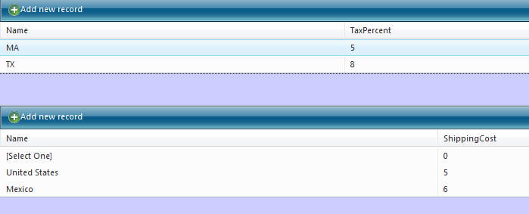

Coupons
Once this is done, let’s add a coupon. Click on Administer Orders > Coupon Admin. Enter in a record as shown below this sentence:
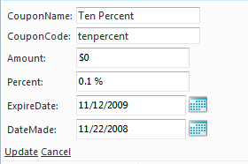
The code is what the user enters to receive the discount in the shopping cart. The amount is the cash amount discount, which must be a negative number to remove money from an order, and the percent is the percent discount. Expire date would tell the system that this coupon expires on that date and date made is the date you made the coupon. Now that this is complete, you need to order some products from your supplier, so that the system will allow you to add products to the cart.

Inventory
In the admin, click on Inventory > Add/View Your Product Suppliers. Add a seller to the RadGrid. Then, click on Inventory > Add Product Orders. Select the product that you added and complete the form. Then, click on Inventory > View Inventory to see what’s in stock:
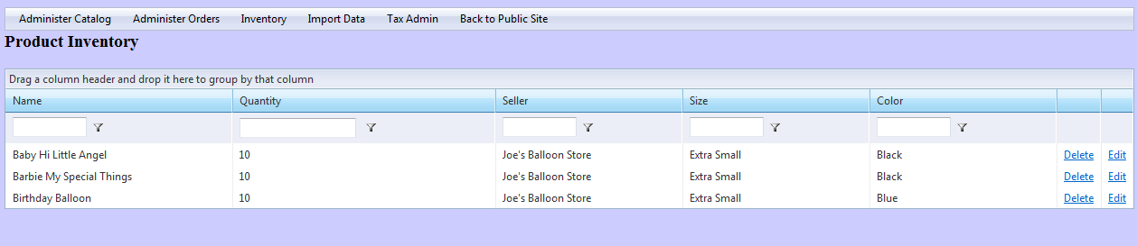
When you are done, click Back to Public Site, on the top menu, to view your product.

